**ASSIGNMENT 5**

1. **Update the first name to 'Johny' for the employee having the first name as 'Bob' in it**

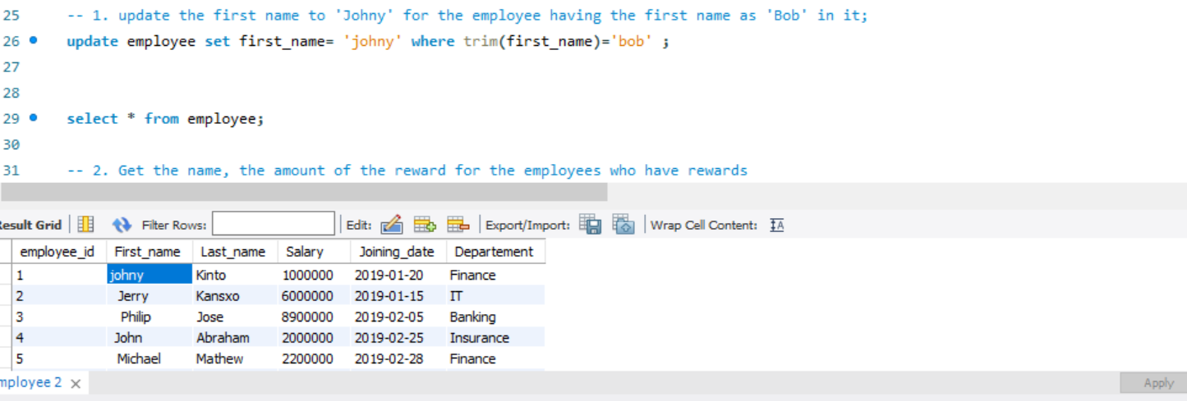

1. **Get the name, the amount of the reward for the employees who have rewards.**

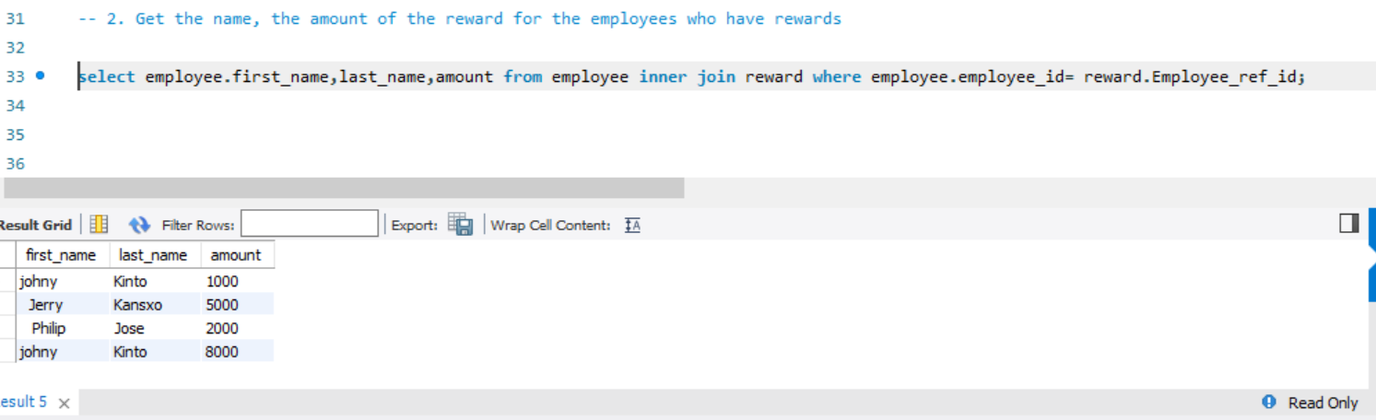

1. **Get the last name, the reward amount for employees who have rewards with an amount greater than 2500**

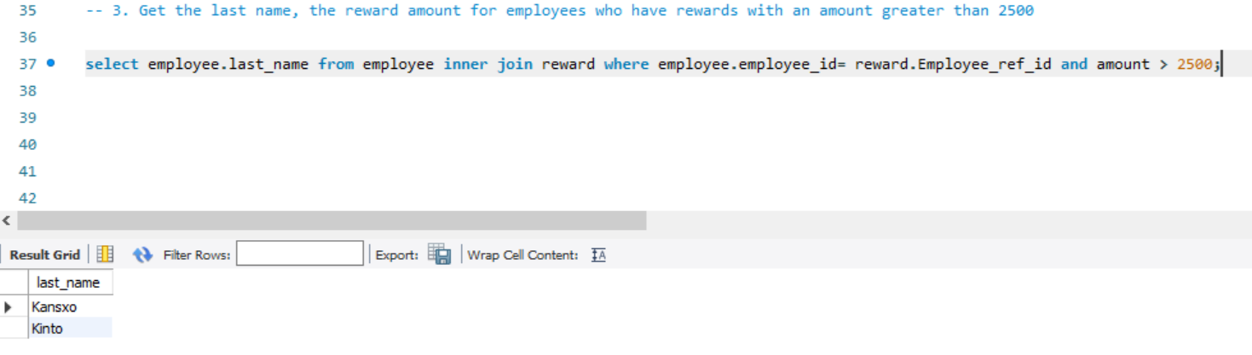

1. **Get the employee name, the amount of the reward for the employees earning salary greater than 1 million, even if they have not received any rewards**

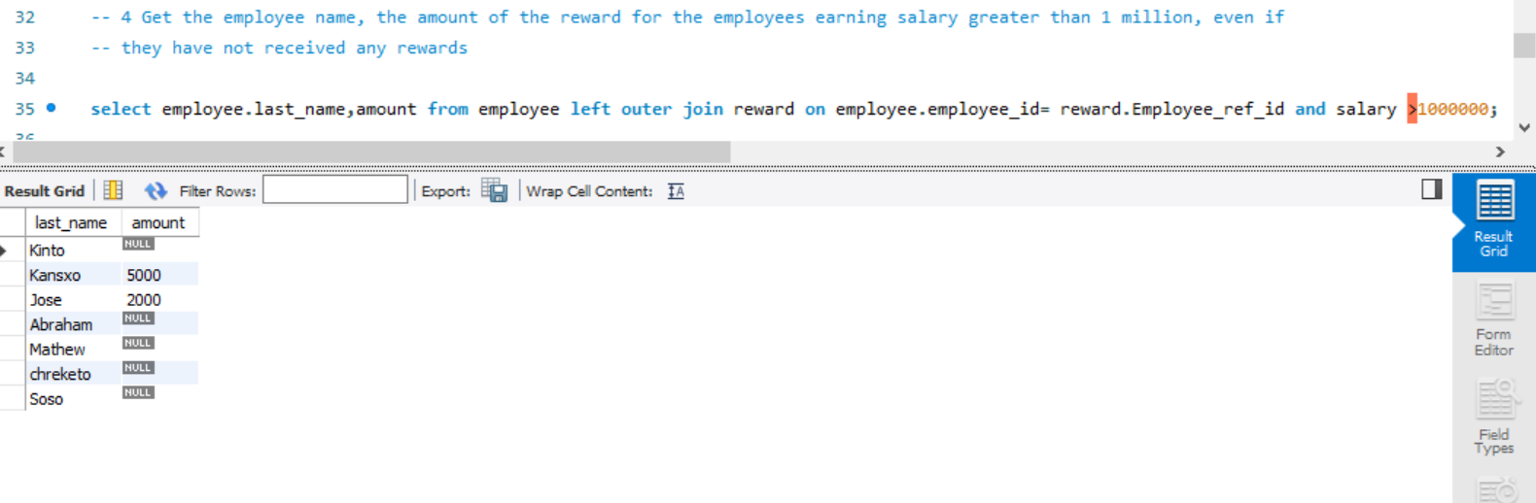

1. **Get total rewards for FINANCE department**

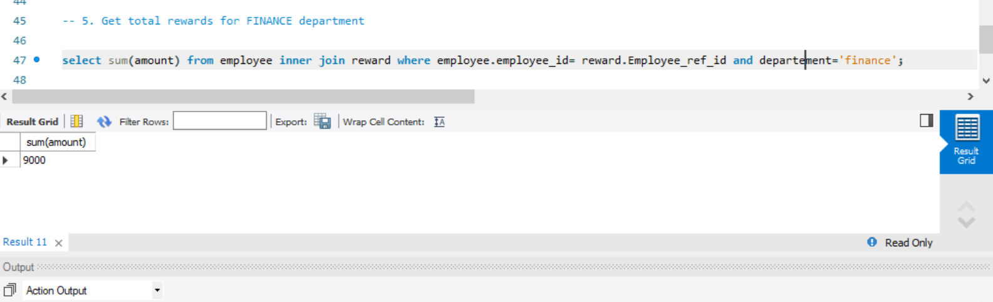

**6. Get total rewards for each department**

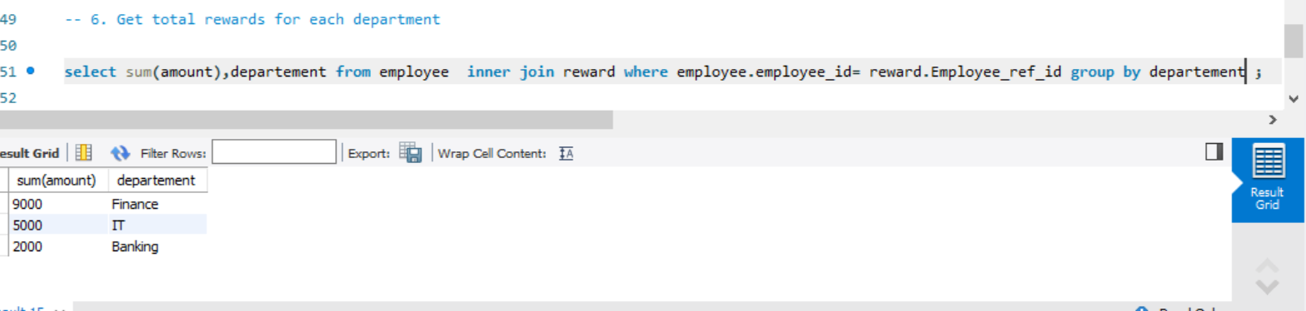

**7. Get net amount taken by each employee who received rewards less than 7500**

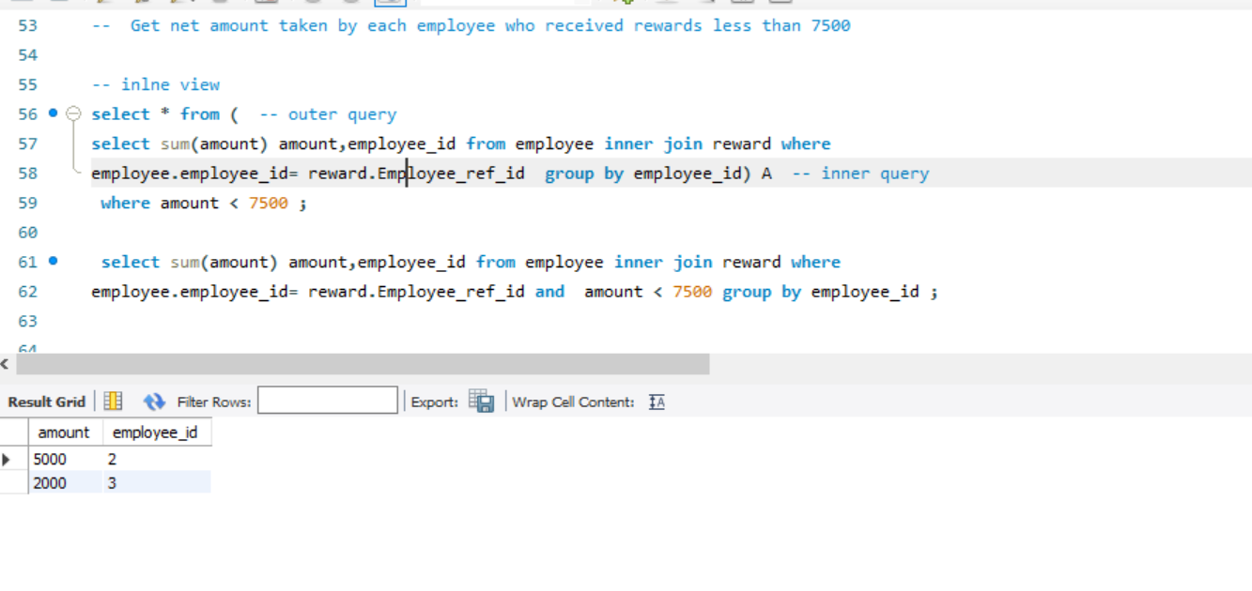

**8. Get the employee name, total amount of the reward for the employees , even if they have not received any rewards.**

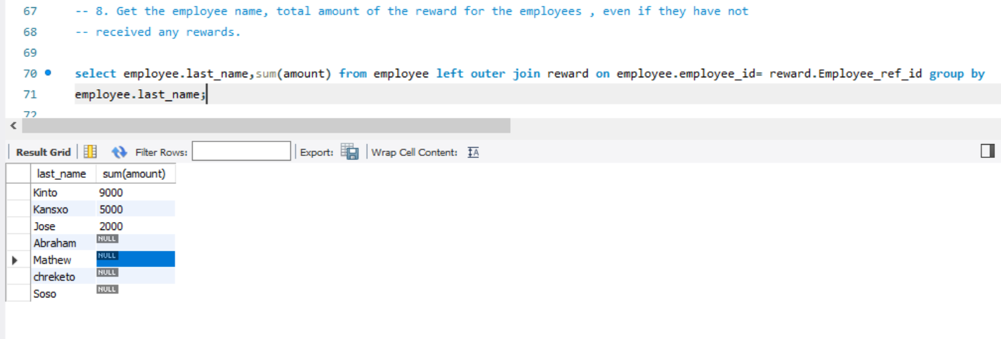

**9.** Get the employee name, total amount of the reward for the employees containing 'john' in their firstname, even if they have not received any rewards.(use: having)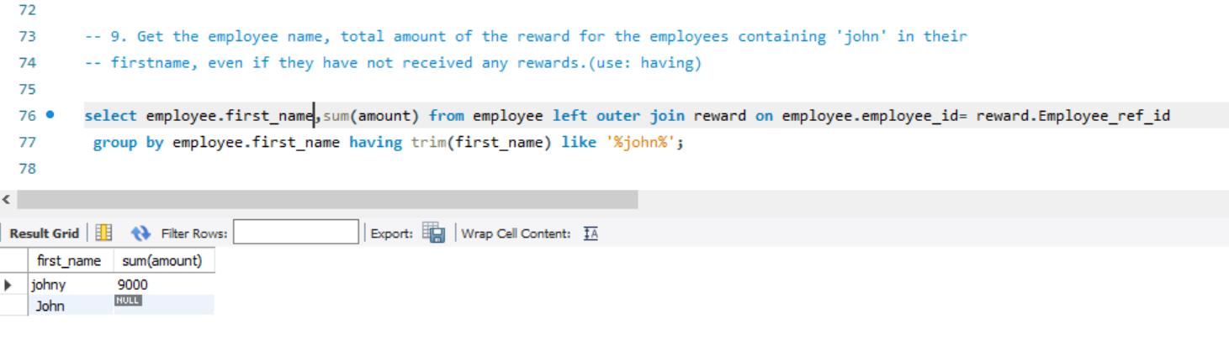

**10.Get the employee name, total amount of the reward for the employees containing 'j' in their firstname, even if they have not received any rewards.(use: where)**

